2. AWS cloud deployment model

The cloud deployment models are:

1. Public.
2. Private.
3. Hybrid.

1. Public cloud:

* These are the cloud services provided by the Cloud provider.
* These can be used by many people simultaneously.

Advantages:

1. No maintenance.
2. No limit for Scalability.
3. High Reliability.

Disadvantages:

1. The hardware components are not in our control.

Use Case Scenario:

1. Deploy website quickly.
2. Focus on development and deployment of self-services.

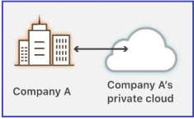

Private Cloud:

* They are similar to the technology we used in previous times, having our own physical data centre.
* They owns the hardware and data centres.

Advantages:

1. More security.
2. Control over the database and hardware.

Disadvantages:

1. Space bound due to less availability of space.
2. Time.
3. Maintenance.
4. Understanding the Hardware and Networking.
5. Difficulty for elasticity (hardware requirements fluctuation).

Use Case Scenarios:

1. Government need to keep the data in our country to avoid the data mishandling.
2. Example: Data of customers in a bank.

Difference between private and public cloud:

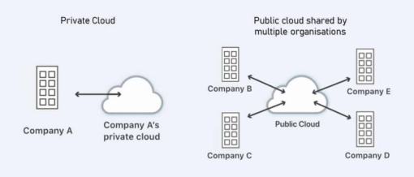

Hybrid Cloud:

* Want to keep the data in the premise and don’t want the data to be exposed to the public.
* Combination of public and private cloud with automation and orchestration between the two.
* Public for the non-critical activities and Private for the critical activities.

Advantages:

1. Use your own equipment to meet security and compliance or legacy scenarios.

Disadvantages:

1. Expensive.
2. Complicated.

Use Case Scenarios:

1. Medical data cannot be exposed to the people.
2. Applications require a specific version of the hardware.

Representation of Hybrid Cloud:

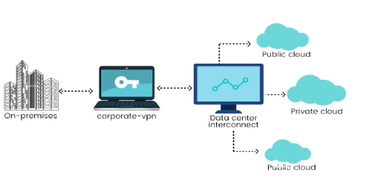

Working of Hybrid Cloud:

* An organization has two types of Cloud models – Public and Private.
* A Public Cloud may contain Networking devices, databases, servers, etc. which can be accessible by both, the Organization Employee and the User, which can do non-critical activities.
* A Private Cloud may contain Networking devices, databases, servers, etc. which can only be accessed by the Organization Employee for Critical Activities.
* A user who wants to access the data from the Public Cloud is allowed, but if he tries to access the data from Private cloud, the request is terminated for security purposes.